|  |
| --- |
|  |
| Design Document Dragon Quest: Warframe Fangame |
| Working Name: Tenno Warrior Quest |

|  |
| --- |
| Tyler Templeton  11/18/2018 |

Table of Contents

1.0 Introduction 4

1.1 Scope 4

2.0 Targeted Systems 4

2.1 Windows 7 4

2.2 Android 4

3.0 Development System 4

3.1 Software 4

4.0 Specification 4

4.1 Concept : Tenno Warrior Quest 4

4.2 Story 5

4.3 game structure 5

4.4 Action 5

4.5 Objective 5

4.5.1 Questing 5

4.5.2 Combat 5

4.6 Graphics 6

4.6.1 Characters & Combat 6

5.0 Gameplay 7

5.1 World 7

5.2 Landscape 7

5.4 Object Types 7

5.5 Control 7

5.5.1 7

6.0 Front End 8

6.1 Intro 8

6.2 Menus 8

7.0 Technical 8

7.1 Stats 8

7.2 Classes 9

7.2.1 Main Character(Hero class) - Excalibur Umbra 9

7.2.3 Mage - Ember 9

7.2.4 Priest - Trinity 9

7.2.5 Jester - Limbo 9

7.2.6 Martial Artist - Valkyr 9

7.2.7 Warrior - Rhino 9

7.2.8 Merchant: - Hydroid or Nekros 9

7.2.9 Sage Class - Oberon 10

7.2.10 Thief - Loki 10

7.3 NPCS 10

8.0 Team 10

9.0 Milestones 11

References 12

# 1.0 Introduction

This Document Specifies a design for the game play of a game with the working title of "Tenno Warrior Quest". This is designed by Tyler Templeton.

## 1.1 Scope

This Document is intended to be read by Programmers, artists and those involved with the creation of this fan game.

# 2.0 Targeted Systems

## 2.1 Windows 7

Windows 7 is the current computer operating system the development is using and since windows 10 has compatibility mode it should work on newer systems.

## 2.2 Android

Due to the nature of the game being menu driven conversion to android is in the possibilities for development

# 3.0 Development System

## 3.1 Software

Development Software that is intended to be used is Unity or GameMaker

# 4.0 Specification

## 4.1 Concept : Tenno Warrior Quest

The concept of the game is to create similar styling and game play as Dragon Quest 3. Will require a spoiler warning before starting due to characters and places. Use of familiar Non Player Characters (NPCs) As the Lotus, Ortis, Konzu and others. The game will use enemies throughout in Warframe. Generic enemies will be used as the basic mobs found in dungeons and over world(s) such and basic Grineer , Corpus, Infested and Corrupted/Orokin. Bosses will draw from Bosses found in the game (Vor, Alan V, Ect ) and potentially secret bosses/boss mobs (such as the Eidolons).

## 4.2 Story

The game takes place in a futuristic space fairing world

Long ago there once was a race know as the Orokin an ancient civilization the once ruled over the Origin System. Now whispers of their return and the threat of destroying the world it is up to the Player and the Tenno to stop them from bring the entire system to ruin.

4.3 game structure

There will be 4 locations with a different graphic style for each (Earth, Venus, Eris ,The Void) . There will be a number of quests to do in each world. This will allow the player to progress through the story.

4.4 Action

The player will explore the planet and its dungeons beginning with Earth. On Earth the player encounters the Grineer, then to Venus to fight the corpus, then to Eris to take on the infested menace, and finally to The Void to face off against the Corrupted Orokin. With each battle the player gets stronger in Experience levels and find and purchase new Equipment to improve and progress.

## 4.5 Objective

### 4.5.1 Questing

The player can interact with NPCs and complete tasks for them. These task can range from kill certain enemies in combat, retrieving an item, or progressing the story. These will reward the player assistance in forms of equipment, progression or information.

### 4.5.2 Combat

Combat is encountered in certain area in the towns or in the over world and dungeons. When encountered the screen will go into the combat mode. Using Turn Based Combat each character gets a turn to do an action from attacking, defending ,using magic or extracting from combat.

## 4.6 Graphics

### 4.6.1 Characters & Combat

Similar to the "retro" style of console game Tenno Warror Quest seeks to emulate this style.

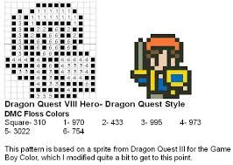

Figure Character Sprite Design (DorkStitch)

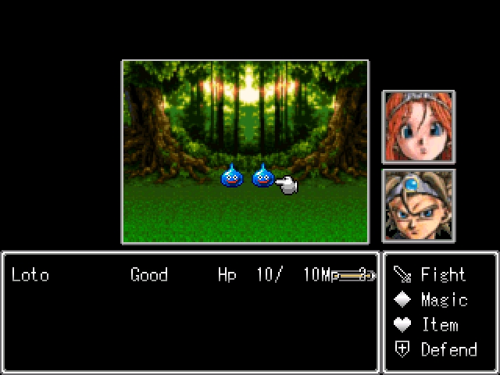

Figure Combat Design (Dragon Quest +)

# 5.0 Gameplay

## 5.1 World

The playing world is multiple screens wide. There will be a number of clear landmarks to indicated areas the player can go to. NPCs can help direct the player where they need to go.

## 5.2 Landscape

The landscape will vary from planet to planet

For Earth it will consist of roads, water, plains, forest, stone and grass tiles

For Venus it's tile set will consist of snow, coolant, metal , dirt/mud

For Eris

For The Void tileset will contain Orokin tower white, tower gold, metal

## 5.4 Object Types

Objects that can appear in the game are:

Chests  
Relics  
Computer terminals

## 5.5 Control

The game will be controlled by a keyboard, possibly Gamepad if supported

### 5.5.1

For the player the controls will be :

Move Left, Right, Up and Down(WASD)

Access menu/ Decline (X)

Confirm selection (Z)

Call Ortis/Lotus (C)

# 6.0 Front End

## 6.1 Intro

There will be image and spoiler warning before entering the game

## 6.2 Menus

The game will use a simple menu system for selecting option, and other things

# 7.0 Technical

## 7.1 Stats

Stats are loosely based on Dragon Quest's stat systems

HP - Hit points, Life value of Frame/ Enemy. Reach 0 they are downed/dead.

EP - Energy Points, used to use skills/spells.

STR - Strength. Represents Physical Damage when using weapons.

ARM - Amour Defence, Reduction of Physical damage, affects HP pool.

AGL - Agility. Determines a Character's priority in turns. Increases evasion/defence

WIS - wisdom scales up EP pool and magic dmg (Intensify) . (DQ 3 - Spell learning, A.I. Efficiency)

LUCK - increases critical chance effects chance to being afflicted by status aliments

## 7.2 Classes

Classes are shown as the Dragon Quest 3's Functional RPG Class which is then converted over to a Warframe Avatar which will assuming similar roles.

### 7.2.1 Main Character(Hero class) - Excalibur Umbra

-All rounder stat wise

-Can equip all Weapons/ Armours

- Spells will be done via Obiter air support(Ortis)

### 7.2.3 Mage - Ember

-High WIS stat based.

-Low STR, and ARM.

- Equips light armour, weapons

-Strong focus on Damaging Spells (Black Magic)

### 7.2.4 Priest - Trinity

-Strongly Focused on healing and buffing abilities.

-Higher STR, AGL, ARM then Mage Counterpart

-Equips light armour, weapons

### 7.2.5 Jester - Limbo

- Used as Built in Hard mode

-Can attack friend or foe alike

-Has higher chance to critical

### 7.2.6 Martial Artist - Valkyr

-High STR, and AGL

-No Spells  
-Stronger with bare hands or claw weapons then other weapons

### 7.2.7 Warrior - Rhino

-High STR ,High ARM

-No spells

- Can equip all Heavy Armour and Weapons

### 7.2.8 Merchant: - Hydroid or Nekros

- Average stats

-Get more money from battles

-Calls Kubrow to Dig for hidden treasure

- Can equip light and medium armour/ Weapons

### 7.2.9 Sage Class - Oberon

- High wisdom

-Low STR and ARM

-Equips only light weapons and armour

- Able to do both Black Magic and White Magic but not to the highest spells

### 7.2.10 Thief - Loki

-High AGI average STR and DEF

-Able to Steal additional items from enemies at the end of battle  
-Able to reduce encounters with ability

## 7.3 NPCS

Big.Bad.Evil.Guy : Tenno Daddy (hey kiddo)?

King: Lotus

Merchant : Baro

Major Quest givers:

Earth - Konzu

Venus - Eudico

Eris - little infested girl?  
 The Void - Lotus/ Ortis

# 8.0 Team

Lead Designer: Tyler Templeton  
Programmer: Tyler Templeton

Sprite Work: Tyler Templeton, TBA

Sound: TBA

9.0 Milestones  
Start Date: November 26th, 2018

Milestone 1 - Planet Design: Earth

Towns

Quests

Dungeons

Encounters

Milestone 2 - Building First town

NPC sprites, dialog

Quest Flagging

Milestone 3 - Over world(Earth)

Combat

Equipment

Experience

Milestone 4 -

# References

missy-tannenbaum. (2010, June 15th). *Dorkstitch*. Retrieved November 18, 2018, from Blogspot: http://dorkstitch.blogspot.com/2010/06/purposely-outdated-looking-dragon-quest.html

Wikipedia. (2018, October 8). *List of character statistics*. Retrieved November 18, 2018, from Wikipedia: reference https://dragon-quest.org/wiki/List_of_character_statistics